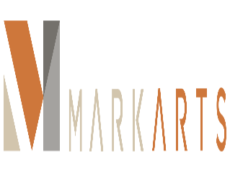

FOR IMMEDIATE RELEASE: September 2, 2016
Contact: Katy Dorrah
Mark Arts
316-634-2787
katy@MarkArtsKS.com
Mark Arts Announces New Trustees
WICHITA, Kan. – Seven business and community leaders have joined the Board of Trustees of Mark Arts as it embarks on the construction of a new educational arts center.
They are:
- David E. Bengtson, attorney at Stinson Leonard Street
- Rebecca Bunting, community volunteer
- Dr. Milt Dougherty, head of school at The Independent School
- Mark Eaton, president of Great Lakes Polymer Technologies
- Angel Gomez, director of guest sales and service at Celebrity Cruises
- Doug Pringle, president of K. T. Wiedemann Foundation
- Christine Voncannon, community volunteer and Designing Women executive chair
“These individuals bring a wealth of knowledge and expertise to Mark Arts,” says Karla Fazio, president of the Board of Trustees. “They will help us immensely as we execute our strategic vision to ensure that future generations have even greater opportunities to explore the arts.”
In addition, community volunteers Paula Varner and Carol Wilson have joined Liz Koch as honorary trustees for Mark Arts. Mark Arts broke ground in June on a new educational arts center at the southwest corner of 13th Street and Rock Road. It is scheduled to open in January 2018.
###
About Mark Arts
The mission of Mark Arts is to be a vibrant arts hub in Wichita and the region by providing opportunities to appreciate and create art in an atmosphere of lifelong learning. It was originally founded in 1920 as the Wichita Art Association, later became The Wichita Center for the Arts and is the area’s oldest visual arts organization. The galleries are open 1 to 5 p.m. Tuesday through Sunday. Admission is free. Visit MarkArtsKS.com or call 316.634.2787.

